

**Question/Answer Booklet**

**Name: Marking key**

**PHYSICAL EDUCATION STUDIES**

**Yr 11 ATAR 2021**

**Semester 1: Class Test 2**

**Time allowed for this paper**

Working time for paper: 45 minutes

**Material required/recommended for this paper**

***To be provided by the supervisor***

This Question/Answer Booklet

|  |  |  |  |
| --- | --- | --- | --- |
| **Contents:**  Functional Anatomy | Multiple choice  Short answers  Extended question | 10 marks  30 marks  10 marks  **Total marks** | **/45** |

**Multiple Choice (10 marks)**

1. Which of the following is not a characteristic of capillaries?

(a) Exchange carbon dioxide and oxygen.

(b) Have thin walls.

(c) Are microscopic.

(d) Have strong elastic walls.

2. The insertion point for the triceps muscle group is located on the:

(a) Ulna.

(b) Radius.

(c) Humerus.

(d) Scapula.

3. Extension of the knee joint involves:

(a) The hamstrings and gastrocnemius coming closer together.

(b) The hamstrings and gastrocnemius moving further apart.

(c) The tibialis anterior and gastrocnemius coming closer together.

(d) The tibialis anterior and gastrocnemius moving further apart.

4. Which of the following muscle groups are antagonistic pairs?

(a) Hamstrings, soleus.

(b) Pectorals, latissimus dorsi.

(c) Trapezius, biceps.

(d) Tibialis posterior, soleus.

5. Identify the joint movement performed by a swimmer’s shoulders during a backstroke race:

(a) Adduction.

(b) Flexion.

(c) Extension.

(d) Circumduction.

6. In which of the following actions would the quadriceps muscles be considered the agonist

(a) pointing your toe.

(b) Bending of the knee in breaststroke.

(c) kicking a soccer ball.

(d) catching a basketball.

Question 7 and 8 refer to the following table.

|  |  |  |  |
| --- | --- | --- | --- |
| **Muscle Fibre Type** | **Contraction Speed** | **Fatigue Rate** | **Force Production** |
| Red Fibres | Low | A | B |
| White Fibres | High | C | D |

7. The correct description at A and C would be

(a) A = high, C = low

(b) A = low, C = high

(c) A = low, C = low

(d) A = high, C = high

8. The correct description at B and D would be

(a) B = high, D = low

(b) B = low, D = high

(c) B = low, D = low

(d) B = high, D = high

9. White blood cells are responsible for

(a) fighting infection

(b) transporting nutrients

(c) blood clotting

(d) transporting nutrients

10. Gaseous exchange occurs between the capillaries and which respiratory system component?

(a) diaphragm

(b) alveoli

(c) pharynx

(d) bronchiole

**Short Answer (30 marks)**

**Question 11 (3 marks)**

**A**

**C**

**B**

Identify the bones A through to C on the diagram below.

**B**

**A**

|  |  |  |
| --- | --- | --- |
| **A. Humerus** | **B. Ulna** | **C. Metacarpals** |

**Question 12 (4 marks)**

**A B**

In reference to the picture above, identify:

|  |  |  |
| --- | --- | --- |
| 1. Joint movement (from A to B) | Abduction | 1 mark each |
| 1. Agonist | Deltoid |
| 1. Origin (of agonist) | Clavicle or Scapula | 1 mark each |
| 1. Insertion (of agonist) | Humerus |

**Question 13 (4 marks)**

The body consists of three types of blood vessels: arteries, veins and capillaries. Compare and contrast **two (2)** characteristics of veins and arteries.

|  |  |
| --- | --- |
| Marks | Possible answers |
| 1 mark each characteristic | Characteristic 1  Arteries have thick elastic walls. Veins have thin, less elastic walls.  Characteristic 2  Arteries carry blood away from the heart. Veins carry blood to the heart.  Characteristic 3  Blood flow in arteries is created by heart beat/pulse. Blood flow in veins is created by muscular contraction.  Characteristic 4  Arteries typically carry blood rich in oxygen. Veins typically carry blood low in oxygen.  Characteristic 5  Arteries do not have valves. Veins contain valves.  NOTE: Answer must mention the characteristic from both arteries AND veins i.e. need to compare and contrast. |

**Question 14 (5 marks)**

Slow-twitch muscle fibres are also known as Type I muscle fibres. Briefly describe **three (3)** characteristics of slow-twitch fibres other than colour that differ from fast-twitch muscle fibres. Identify one activity suited to slow-twitch muscle fibres providing a reason for your answer.

|  |  |
| --- | --- |
| Marks | Possible answer |
| 1 mark for each correct answer | Any three of the following  *Slow-twitch muscle fibres:*   * Produce energy from the aerobic pathway * Have a slow contraction speed * Low force production * Have a high resistance to fatigue * Fibres are small in diameter * Have low PC stores * High amount of oxidative enzymes * High myoglobin content * High mitochondria density |
| 1 mark for activity  1 mark for reason | Identifies suitable activity – i.e. aerobic/endurance activity  Reasoning – links requirements of activity to fibre characteristic |

**Question 15 (4 marks)**

One of the major functions of the circulatory system is to circulate blood to the body. Describe **two (2)** other functions.

1. Transport O2, water and nutrients **to** cells in the blood
2. Transport CO2 and wastes **away** from the cells
3. Maintain body temperature
4. White blood cells fight infection

**Question 16 (6 marks)**

Identify the **muscles** A through to F on the diagram below.

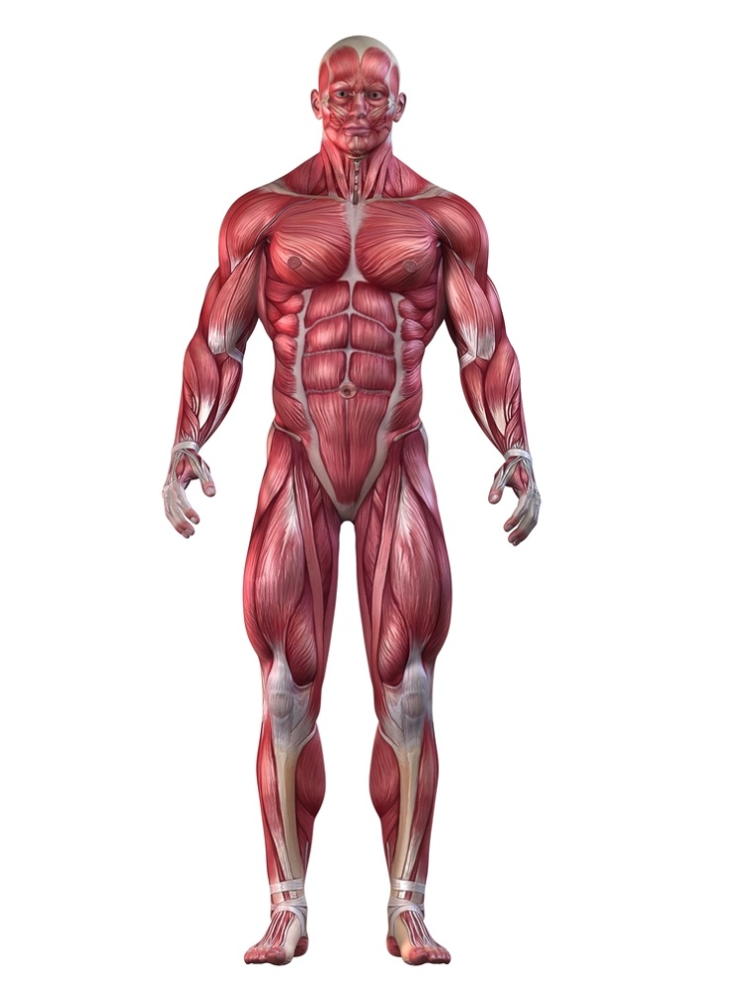

**A**

**B**

**C**

**D**

**E**

**F**

|  |  |  |
| --- | --- | --- |
| **A. Trapezius/sternomastoid** | **B. Deltoid** | **C. Biceps** |
| **D. Abdominals** | **E. Quadriceps** | **F. Tibialis Anterior** |

**Question 17 (4 marks)**

Complete the table below, naming and defining the characteristics of skeletal muscle.

1 mark per correct name and definition (max of 4 marks)

|  |  |
| --- | --- |
| Marks | Elaboration |
| *Excitability* | *The ability of a muscle to contract in response to a signal or nerve impulse sent from the Central Nervous System* |
| *Contractibility* | *The ability of a muscle to shorten or reduce in length (or similar definition)* |
| *Extendibility* | *The ability of a muscle to stretch beyond its regular resting length* |
| *Elasticity* | *The ability of a muscle to return back to its original resting length after being stretched (or similar definition)* |

(4 marks)

**Extended Answer (10 marks)**

**Question 18 (10 marks)**

From the point of inhalation, describe the mechanics of breathing, including pressure change and flow of oxygen through the cardiorespiratory system to supply oxygen to the working muscle/s.

|  |  |
| --- | --- |
| Marks | Possible answer |
| 1 mark for identification of 8 **structures**  must appear in correct order  2 marks for pressure change | * **Diaphragm** contracts/moves downward to increase space available * **Ribs** rise to increase space available * Oxygen enters the body via the **mouth/nose** * **Lungs** expand/fill with air. Oxygen travels down through the **pharynx, larynx** and **trachea** into the **bronchi** and **bronchioles**. * Gas exchange occurs at the **alveoli** * *Pressure change* – Oxygen pressure in the alveoli is higher than that in the surrounding capillary. As a result, oxygen will move from an area of high pressure to an area of low pressure i.e. from the alveoli to the capillary, via diffusion. * Oxygen returns to the heart via the **pulmonary veins**. * Blood enters the **left atrium**, * Followed by the **left ventricle**. * Blood exits the heart via the **aorta** to travel to the **working muscles** to exchange oxygen, carbon dioxide and waste products |